Registration RSVP

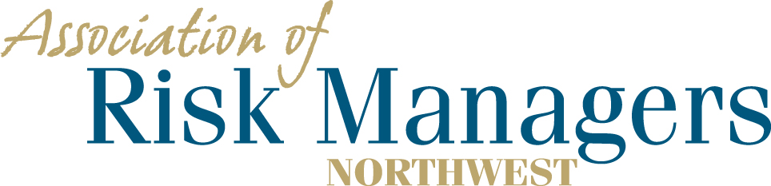

Tuesday and Wednesday March 3rd and 4th, 2020
DoubleTree Suites, 16500 Southcenter Parkway, Seattle, WA 98188

Please arrange for your overnight accommodations by calling – 1-800-222-8733
Rooms have been reserved under Association of Risk Managers Northwest. Please call before February 18th.
Guaranteed room rate $189 for a single king or 2 queen beds plus tax.

Agency _____________________________________________

(Please circle the meals that each person intends to have.)
1._________________________________ 3/3 Dinner 3/4 Breakfast 3/4 Lunch
2._________________________________ 3/3 Dinner 3/4 Breakfast 3/4 Lunch 3._________________________________ 3/3 Dinner 3/4 Breakfast 3/4 Lunch
4._________________________________ 3/3 Dinner 3/4 Breakfast 3/4 Lunch

Registration Fee Per/Person = $75 ____________

Total Remitted ____________

Please return registration / RSVP to AofRM Northwest, by February 18, 2020
Please make checks payable to Association of Risk Managers Northwest
Mail remittance to: Association of Risk Managers PO Box 6974, Tacoma, WA 98417
Include registration / RSVP with your remittance
Remember to arrange for your overight accomodations by February 18, 2020
Contact Sue Knobeloch phone; 253-301-3988, cell, 253-905-5484 ; or sknobeloch@armnw.com with questions

