Registration / RSVP

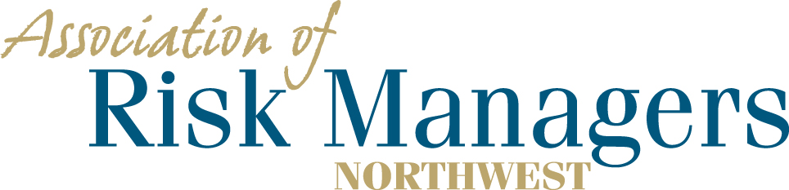

Tuesday and Wednesday, June 23rd & 24th, 2020
La Quinta Inn & Suites, 1425 E. 27th St., Tacoma, WA 98421

Please arrange for your overnight accommodations by calling – 1-253-383-0146
Rooms have been reserved under Association of Risk Managers Northwest and will be held until May 22nd.
Guaranteed room rate $99.00 plus tax

Agency _____________________________________________

Agency Representatives Attending.

(Please circle the meals that each agency representative intends to have.

1._______________________ 6/23 Dinner 6/24 Breakfast 6/24 Lunch
2._______________________ 6/23 Dinner 6/24 Breakfast 6/24 Lunch 3._______________________ 6/23 Dinner 6/24 Breakfast 6/24 Lunch 4._______________________ 6/23 Dinner 6/24 Breakfast 6/24 Lunch

Registration Fee Per/Person = $75 ____________

Total Remitted ____________

- Please return registration / RSVP to AofRM Northwest, by June 10th, 2020
- Please make checks payable to Association of Risk Managers Northwest
- Mail remittance to: Association of Risk Managers PO Box 6974, Tacoma, WA 98417
- Include registration / RSVP with your remittance
- Remember to arrange for your overight accomodations by May 22, 2020
- Contact Sue Knobeloch 253-301-3988 or 253-905-5484; sknobeloch@armnw.com with questions

