Registration/Sponsorship RSVP

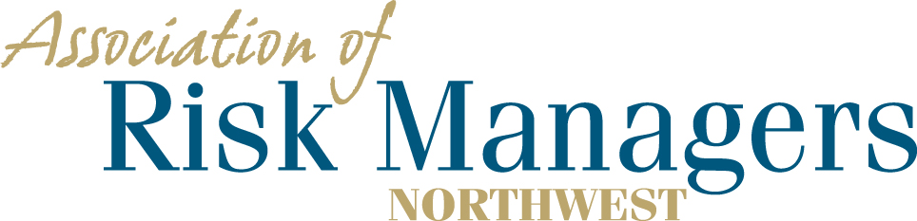

Tuesday and Wednesday - June 23rd & 24th, 2020
La Quinta Inn & Suites, 1425 E. 27th St, Tacoma, WA 98421

Please arrange for your overnight accommodations by calling – 1-253-383-0146
Rooms have been reserved under Association of Risk Managers Northwest. Please call before 5/22/2020
Guaranteed room rate $99.00 plus tax

Company _____________________________________________

Company Representatives Attending
(Please circle the meals that each company representative intends to have.)

1._________________________________ 6/23 Dinner 6/24 Breakfast 6/24 Lunch
2._________________________________ 6/23 Dinner 6/24 Breakfast 6/24 Lunch
3._________________________________ 6/23 Dinner 6/24 Breakfast 6/24 Lunch
4._________________________________ 6/23 Dinner 6/24 Breakfast 6/24 Lunch

Registration Fee Per/Person = $175.00 ____________

Company Sponsorship ____________

Total Remitted ____________

- Please return registration / RSVP to AofRM Northwest, by June 10, 2020
- Please make checks payable to Association of Risk Managers Northwest
- Mail remittance to: Association of Risk Managers PO Box 6974, Tacoma, WA 98417
- Include registration / RSVP with your remittance
- Remember to arrange for your ovenight accommodations by May 22, 2020
- Contact Sue Knobeloch 253-301-3988 or 253-905-5484; sknobeloch@armnw.com with questions

