Registration RSVP

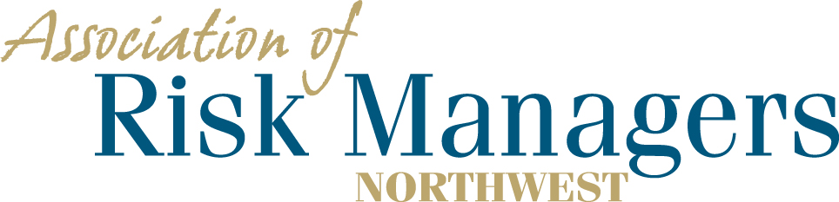

Tuesday and Wednesday – March 9th & 10th, 2021
LaQuinta Inn & Suites, 1425 E 27th St, Tacoma, WA 98421

Please arrange for your overnight accommodations by calling – 1-253-383-0146 Ext 5
Rooms have been reserved under Association of Risk Managers Northwest. Please call before 2/8/21
Guaranteed room rate $99.00 for a single king, single king suite, or 2 queen beds plus tax and a $1.50 tourism fee and will be allowed 1 day prior and after the meeting dates.

Company Partner: _____________________________________________

(Please circle the meals that each person intends to have.) – Breakfast is included in room rate
1._________________________________ 3/9 Dinner 3/10 Breakfast 3/10 Lunch
2._________________________________ 3/9 Dinner 3/10 Breakfast 3/10 Lunch 3._________________________________ 3/9 Dinner 3/10 Breakfast 3/10 Lunch
4._________________________________ 3/9 Dinner 3/10 Breakfast 3/10 Lunch
3/9 Dinner 3/10 Breakfast 3/10 Lunch

Registration Fee Per/Person = $175 ____________
Sponsorship: ____________
Total Remitted ____________

Please return registration / RSVP to AofRM Northwest, by February 15, 2021
Please make checks payable to Association of Risk Managers Northwest
Mail remittance to: Association of Risk Managers PO Box 6974, Tacoma, WA 98417
Include registration / RSVP with your remittance
Remember to arrange for your overight accomodations by February 8, 2021
Contact Sue Knobeloch phone; 253-301-3988, cell, 253-905-5484 ; or sknobeloch@armnw.com with questions

