Registration RSVP

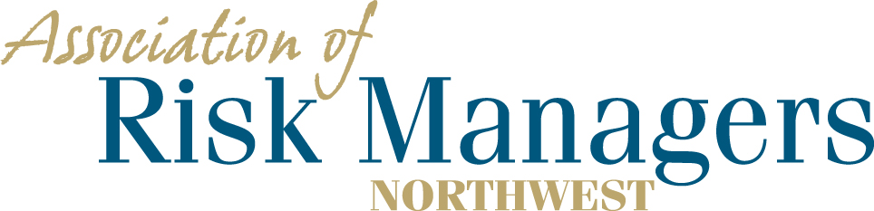
Tuesday & Wednesday – June 15th & 16th, 2021
Historic Davenport Hotel, 10 South Post Street, Spokane, WA 99201

Please arrange for your overnight accommodations by calling – 1-800-288-9290
Rooms have been reserved under Association of Risk Managers Northwest. Please call before 5/21/2021
Guaranteed room rate $169.00 for a single king or 2 queen beds plus tax and a $12.00 Destination Amenity Fee and will be allowed 1 day prior and after the meeting dates. Parking will e discounted to $10 @ day.

Agency _____________________________________________

(Please circle the meals that each person intends to have.)
1._________________________________ 6/15 Dinner 6/15 Breakfast 6/15 Lunch
2._________________________________ 6/15 Dinner 6/15 Breakfast 6/15 Lunch
3._________________________________ 6/15 Dinner 6/15 Breakfast 6/15 Lunch
4._________________________________ 6/15 Dinner 6/15 Breakfast 6/15 Lunch

Registration Fee Per/Person = $75 ____________

Total Remitted ____________

Please return registration / RSVP to AofRM Northwest, by May 14, 2021
Please make checks payable to Association of Risk Managers Northwest
Mail remittance to: Association of Risk Managers PO Box 6974, Tacoma, WA 98417
Include registration / RSVP with your remittance
Remember to arrange for your overight accomodations by 5/21/2021
Contact Sue Knobeloch phone; 253-301-3988, cell, 253-905-5484 ; or sknobeloch@armnw.com with questions

