Registration RSVP

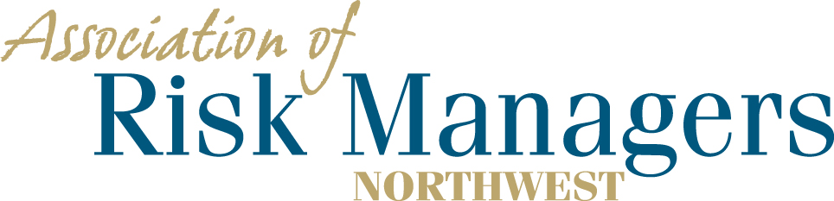
Tuesday & Wednesday – October 5th & 6th, 2021
7 Cedars Resort & Casino – 270756 HWY 101, Sequim, WA 98382

Please arrange for your overnight accommodations by calling – 1-360-683-7777
Rooms have been reserved under Association of Risk Managers Northwest. Please call before 9/3/2021
Guaranteed room rate $189.00 for a single king or 2 queen beds plus tax and will be allowed 1 day prior and after the meeting dates.

Agency _____________________________________________

(Please circle the meals that each person intends to have.)
1._________________________________ 10/5 Dinner 10/ 6 Breakfast 10/6 Lunch
2._________________________________ 10/5 Dinner 10/ 6 Breakfast 10/6 Lunch
3._________________________________ 10/5 Dinner 10/ 6 Breakfast 10/6 Lunch
4._________________________________ 10/5 Dinner 10/ 6 Breakfast 10/6 Lunch

Registration Fee Per/Person = $75 ____________

Total Remitted ____________

Please return registration / RSVP to AofRM Northwest, by September 15th, 2021
Please make checks payable to Association of Risk Managers Northwest
Mail remittance to: Association of Risk Managers PO Box 6974, Tacoma, WA 98417
Include registration / RSVP with your remittance
Remember to arrange for your overight accomodations by September 3rd, 2021
Contact Sue Knobeloch phone; 253-301-3988, cell, 253-905-5484 ; or sknobeloch@armnw.com with questions

