Registration RSVP

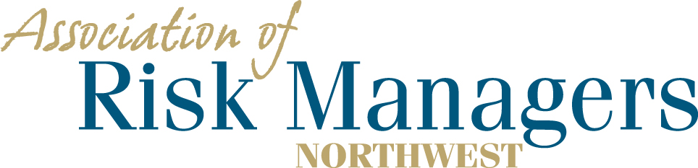

Tuesday and Wednesday – June 14th & 15th, 2022
DoubleTree Suites by Hilton, 16500 Southcenter Parkway, Seattle

Please arrange for your overnight accommodations by calling – 1-206-575-8220
Rooms have been reserved under Association of Risk Managers Northwest. Please call before 5/14/2022
Guaranteed room rate $204.00 for a single king, single queen or 2 queen beds plus tax and a 12.4% Occupancy tax rate and will be allowed 1 day prior and after the meeting dates. Parking fees have been waived.

Company Partner: _____________________________________________

(Please circle the meals that each person intends to have.) –
1._________________________________ 6/14 Dinner 6/15 Breakfast 6/15Lunch
2._________________________________ 6/14 Dinner 6/15 Breakfast 6/15Lunch
3._________________________________ 6/14 Dinner 6/15 Breakfast 6/15Lunch
4._________________________________ 6/14 Dinner 6/15 Breakfast 6/15Lunch

Registration Fee Per/Person = $175 ____________
Sponsorship: ____________
Total Remitted ____________

Please return registration / RSVP to AofRM Northwest, by June 1, 2022
Please make checks payable to Association of Risk Managers Northwest
Mail remittance to: Association of Risk Managers PO Box 6974, Tacoma, WA 98417
Include registration / RSVP with your remittance
Remember to arrange for your overight accomodations by May 14, 2022
Contact Sue Knobeloch phone; 253-301-3988, cell, 253-905-5484 ; or sknobeloch@armnw.com with questions

